Rail & Commuter Transport plan for East Wicklow
January 2018. Submission to DART+ Plan & Update, September 2020.
© Cllr. Derek mitchell, BAI, FCA, MSc.
dmitchell@wicklowcoco.ie
B

This is a Draft submission is from Wicklow’s Strategic Policy Committee on Transport, Wicklow County Council and is to be submitted by 7th October 2020 to the DART+ Maynooth line-Option s Selection Report Public Consultation Process. Submissions to: DARTMaynooth@irishrail.ie
Draft C 23/9/20

©

Summary

The detailed plan to electrify the railway to Maynooth & Meath M3 Parkway (MM) is published. This cancels direct trains from Wicklow/Wexford to Dublin in order to allow the Western trains onto the North-South line. It includes peak hour schedules from Hazelhatch to Dublin as well. It will shuttle the Rosslare train to Greystones where passengers will transfer to the existing 2 DARTs in the peak hour. All of these trains are full now and it will increase journey times by 11 mins at least. Arklow will be a comparable time to Belfast.

The result will be a shift of people to cars on the N11 through the Glen o’ Downes and around Bray, all of which are well over capacity. This is the direct opposite of Wicklow County Council policy and NTA Strategy; ‘faster and more frequent intercity, regional and DART services will be provided on this (South Eastern) Line’.

A shuttle has been a failure previously, illustrated by the photo of the 1992 Anti Shuttle march (p2). The reasons it will fail again are detailed in the original paper.

The 240 page DART+ Plan gives no thought as to how the N11 or bus services will cope with this displacement from rail. It does however allow Belfast, Sligo & Cork line diesels to get to Dublin but not the South East ones.

Solution: Of the 13 peak hour trains from MM to Connolly, 2 (or possibly 4) should go to Spencer Dock instead of joining the North South line, leaving space for 2 peak hour Wicklow trains. The modelling should be run taking the Wicklow/Wexford service into account, including increasing the length to 8 carriages. This should be supported by a bus lane, with Express Buses, on the N11 from Newtown. The study on this is well behind schedule.

The population is expanding as required by the Department of Environment population target instructions and proper public transport is required. The line was built as the Dublin & South Eastern Railway in the mid 1850s and the South Eastern trains to Dublin must not be cancelled.

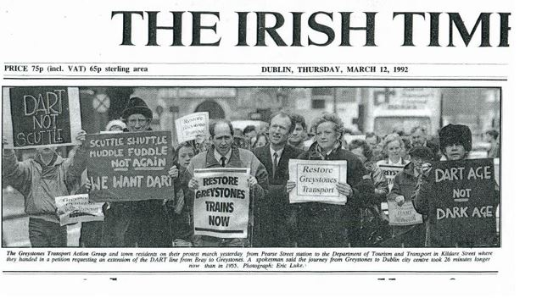
March 11, 1992 march protesting at shuttle service and demanding the extension of the DART to Greystones
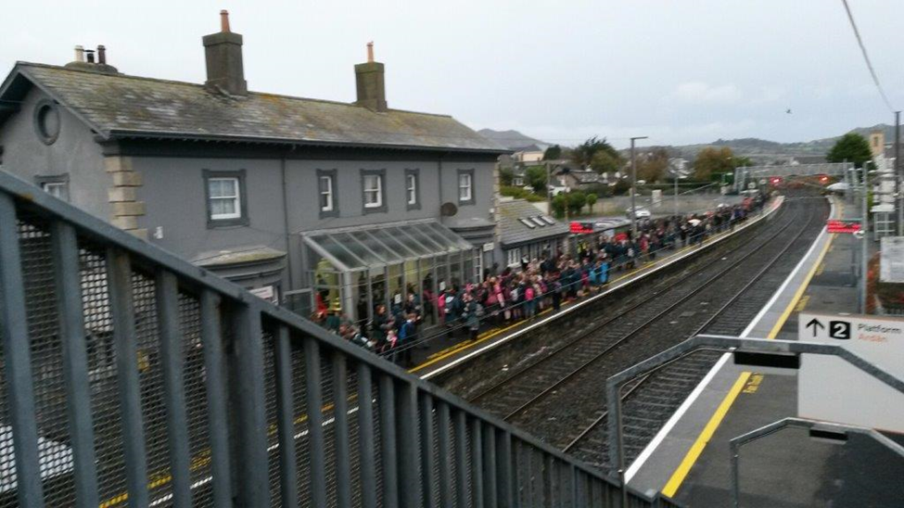
Crowds wait for 08.00 DART at Greystones Station
The 2018 Rail & Commuter plan for East Wicklow provides for a tripling of rush hour rail capacity and an express bus service on the N11 with Park n’ Ride, at a limited cost. This update details progress by item heading. It is also a submission to the DART+ to Maynooth consultation which closes on the 7th October.
https://www.irishrail.ie/en-ie/about-us/iarnrod-eireann-projects-and-investments/dart-programme/dart-west-public-consultation

RAIL Changes implemented since plan. The DART service to Bray frequency was increased in 2018 from 15 to 10 minutes. Also the trains were slowed down by about 8% (Greystones +6min, Arklow +9 min), no reason given. Reliability seemed to suffer possibly due to problems with admitting the Western trains at the ‘at grade junction’ north of Connolly. There are 2 working hour diesels, 6.33 (ex Gorey) & 7.30 (ex Wexford) am, leaving Wicklow, the first being considered before the ‘peak hour’. 328 passengers used the Wicklow service in 2018.
The Maynooth DART line is first for electrification with completion expected in late 2024. A station at Woodbrook is planned which will delay Wicklow trains by 2 mins as it is on a currently fast section.

Wicklow’s 2018 Rail Plan.
Increase Rail service to Kilcoole, Wicklow Town, Rathdrum & Arklow with 3rd rush hour train and doubling length to 8 carriages. This would give a four times capacity increase for a limited cost. These are the only stations in the GDA with less than 3 peak services. This appears to be rejected.

The Maynooth & M3 Parkway DART+ plan has been published and consultation closes on 7th October 2020,
FIG 3-10 Working timetable, p67, & Peak Hour Service Plan, Annex-3-4A, removes the 1 service to Wicklow /Wexford to allow 13 Western services to use the line to Connolly & South. Greystones will have 2 at the peak hour to Maynooth. Wicklow will have 1 peak hour to Greystones. In contrast the direct Sligo & Belfast diesels to Connolly are to continue interworking with the DART.
A Shuttle will increase journey time by a further 11.5 mins (+7.5 transfer, signalling issue per 2018 paper +2, Woodbrook +2). Arklow 118 min comparable to Belfast 129 min. No studies appear to be done but the single track restrictions will likely limit capacity to current capacity or less even though it is difficult to get on the trains. As detailed in the 2018 paper shuttles have a bad history on the line even creating anti shuttle marches.
The 2018 paper gave 6 ways of having longer trains. The Selective Door Opening has since been ruled out by not being included in the large order for carriages. However battery trains are to be considered for the Drogheda Service. Possibly these could be used to Arklow if feasible.

Solution.
The Irish Academy of Engineers Plan for western services to go to a revamped Docklands Station along the 2 double track railways in North Central Dublin and not to disrupt existing services to Wicklow on the one North South line should be implemented. Leaving the train interval on the South East line at 10 mins and not moving to 6 would allow space for 2 peak hour Wicklow trains. South East Dublin is a low density area, beside the sea, and this should be a satisfactory frequency. At a minimum 2 (or possibly 4) Maynooth & M3 Services should be rerouted from Connolly to Spencer Dock to allow space for the 2 Wicklow trains

Increase DART frequency to Greystones. In Progress.
Having studied the timings it showed that partially double tracking from Greystones to the tunnel and a shorter distance on the Bray side would allow frequency to increase to every 20 mins (from 30 min) without tunnelling. The NTA got Jacobs to check this and it is now included in the National Development Plan. In May 2020 Irish Rail tendered for the design of the track, signalling and electrics for the coastal DART Line from Drogheda to Greystones, including Greystones to Bray frequency enhancement and a possible 3 rd platform in Greystones for a possible shuttle.

Park n’ Ride. The NDP includes expanding this at Greystones as the 500 spaces are full.

Erosion. The rail track is at risk from erosion. A joint 2018 Irish Rail/WicklowCC study is awaited.

Road.
2018 plan recommended express buses on N11, with Park n’ Ride and bike parking. TII started a study about upgrading the N11 in 2018 with consultation in late 2019. This showed consideration being given to significant road improvements both North & South of Kilmacanoge. The consultants were then asked to report on how a bus lane could work and expected to report in early Summer 2020. Covid 19 disrupted this and no report date is known. It was also supposed to study whether the railway could relieve traffic but this does not seem to have happened. The NTA expressed a willingness to run express buses if they could get through the traffic.
The Glen o’ Downes is a major choke point, some suggesting that a bus lane should use the hard shoulder, but without noticing that there is no hard shoulder in the Glen.

Bus.
Bus Connects is reorganising all Dublin Bus routes after much consultation. However it does not provide good bus journey times to major employment centres on the M50 such as Sandyford & West Dublin. Longer distance services are slow and have journey times close to Belfast to Dublin services.
The 133 service has been increased along the N11.
Aircoach 702 service Greystones/Bray to Airport 1.23 mins,
Wexford Bus. Arklow to Airport 1.45 mins. (Belfast 705 to Airport 1.50 min)

Wicklow population growing at twice Dublin rate.
From 2002 to 2016 growth Dublin City Co 12%, Wicklow 24%, DLRCC 13%, EMRA 25%.
There has been substantial growth in some places with houses completed or commenced since the 2016 Census of: Greystones 1600, Newtown 900, Wicklow 900.
In addition Cherrywood, with a population similar to Bray, will be populated soon without any increase in public transport. The Metro to Sandyford and thus the LUAS to Bray having both been postponed without target completion dates. This will result in major congestion on the M50 & N11.
45% of Wicklow’s population is in the Metropolitan Area, obliged to take high density development, and all Wicklow is part of the GDA. The increase in journey time on rail & road due to prioritisation of shorter journeys is a concern to Wicklow.
Road Space Allocation & Speed.
Much greater emphasis is being given to short distance methods of transport such as walking, cycling, LUAS for limited road space in Dublin City and Dun Laoghaire. This slows down Wicklow’s cars and buses which are needed for longer distance travel resulting in more cars on the M50 to access Dublin & the Airport. Recent proposals to limit speed in all Dublin to 30 kph halve the speed of Wicklow buses even though Wicklow’s population is expanding so much faster than Dublin. A submission on this was made asking that routes of Wicklow Buses & the Port Tunnel to N11 route would remain at 50 kph. This was not supported by the NTA.
Also it appears to the author that traffic light sequences on the N11 have been altered to give less priority to through traffic at places such as Cabinteely & Cherrywood junctions.

The Author: A Councillor representing Greystones. He spent 22 years leading the campaign to extend the DART to Greystones. Also 20 years leading the campaign to rebuild Greystones harbour as the focal point for the town and Community Recreational Centre.

