Update on Fairfield Park

Fairfield Park in Greystones has provided private rented accommodation to households since 1973. In August 2016, 48 households were issued with Notice to Quit with an effective date of 31st August 2017. This presented a significant added challenge to Wicklow County Council, with over 3,200 on the Housing list and over 500 Homeless presentations per annum.

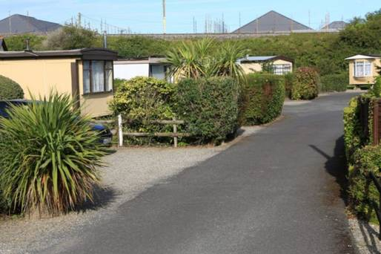

The Council immediately proactively engaged with the landlord and the residents and engaged the services of a Housing Support Worker from the Simon Community to assist Council staff in the provision of Tenancy Sustainment and Housing Support services.

The project brief was to prevent anyone currently living in Fairfield Park becoming homeless by:

- Assessing every household individually to determine housing need
- Ensuring all eligible households were registered for Social Housing Support
- Ensuring all eligible households receive rent supplement/HAP where appropriate
- Actively engaging with landlords and agents to create rental opportunities
- Providing post-tenancy support where necessary.

All residents were interviewed, their initial assessment completed and a priority list was devised which informed the proposed exit pathway for each household.

Profile of residents:
- 52 units of which 48 were occupied
- 55 adults (7 couples and 41 singles)
- 6 families with 7 dependants/children

A site clinic was set up with a constant presence from Dublin Simon and visiting support from Wicklow County Council. This greatly facilitated the residents, many of whom were elderly and/or infirm and had been resident in Fairfield Park since the 1970s.

Many challenges faced the team including:
- Initially residents reluctant to engage/think about leaving
- Lack of social network supports for some residents
- Property availability and affordability
- Promotion of HAP with residents and landlords
- Accessing deposit/first month rent

An interagency approach was critical to achieving a positive solution – the team liaised daily with Social Workers, Gardai, legal services, Tusla, medical and addiction services, Department of Social Protection and Approved Housing Bodies. The Homeless Team, the HAP/RAS team and the Allocations Officer were significantly involved in this process.
Outcome: The percentage of transitioned households is now at 100% with transitions being achieved through a mix of sourcing private rented accommodation some with HAP and RAS, successful referrals to AHBs and allocation of some Social Housing units.
Category | Total
Local Authority Social Housing | 7
Approved Housing Body | 3
Rental Assistance Scheme | 5
Housing Assistance Payment | 8
Private Rented | 15
House Purchase | 2
Family | 6
RIP | 2
Tenancy sustainment and continuation of support services to the more vulnerable of the residents accommodated is critical and ongoing.
The feedback from all the clients assisted into alternative accommodation has been extremely positive and all have expressed their satisfaction with the holistic, supportive and enabling support services provided by the Council in this case.

